How to Set Up Work Centers and Routing in Odoo 19 – Complete Guide
Rohan Raj | Feb 25, 2026
In manufacturing, products are built through a series of steps that happen at specific stations within the factory. A desk may go through cutting, machining, painting, assembly, quality testing and packaging before it is ready for delivery. Each of these steps happens at a particular location with specific equipment and operators. In Odoo 19, these production stations are called Work Centers and the sequence of steps is defined through Operations on the Bill of Materials, which together form the Routing for the product. Configuring work centers and routing allows Odoo to schedule production, calculate manufacturing costs per operation, generate individual work orders for each step and track the performance of each station.

Understanding Work Centers
A Work Center in Odoo represents a physical station or area in the factory where a specific type of work is performed. This can be a cutting table, a CNC machine, a welding booth, an assembly line, a quality inspection bench or a packaging counter. Each work center carries parameters that affect production scheduling and cost calculation.
The key parameters on a work center are the cost per hour, which determines the hourly operating cost of that station, the setup time, which is the preparation time needed before each operation begins, the cleanup time, which is the time needed to reset the station after each operation ends, the time efficiency, which adjusts the expected duration to reflect the actual speed of the station, and the OEE target, which sets the minimum Overall Equipment Effectiveness benchmark for performance tracking.
Work centers can also have Alternative Work Centers configured. An alternative work center is a backup station that can perform the same operation when the primary station is busy or under maintenance. In addition, Product Capacities can be defined to specify how many units of a particular product can be processed simultaneously at a work center.

Understanding Routing
Routing in Odoo 19 is defined through Operations on the Bill of Materials. Each operation specifies the name of the step, the work center where it happens and the expected duration in minutes. The operations are listed in order on the BoM, and Odoo executes them in that order when generating work orders for a Manufacturing Order.
When a Manufacturing Order is created and confirmed for a product that has operations on its BoM, Odoo automatically generates Work Orders — one for each operation. These work orders can be tracked, started, paused and completed individually through the Manufacturing application or the Shop Floor interface.

Enabling Work Orders
The Work Orders feature must be enabled before work centers and routing can be used.

Manufacturing Application => Configuration => Settings
Under the Operations section, enable the Work Orders checkbox. Optionally, enable Work Order Dependencies if operations need to follow a strict sequence where one step must complete before the next can begin. Click Save.
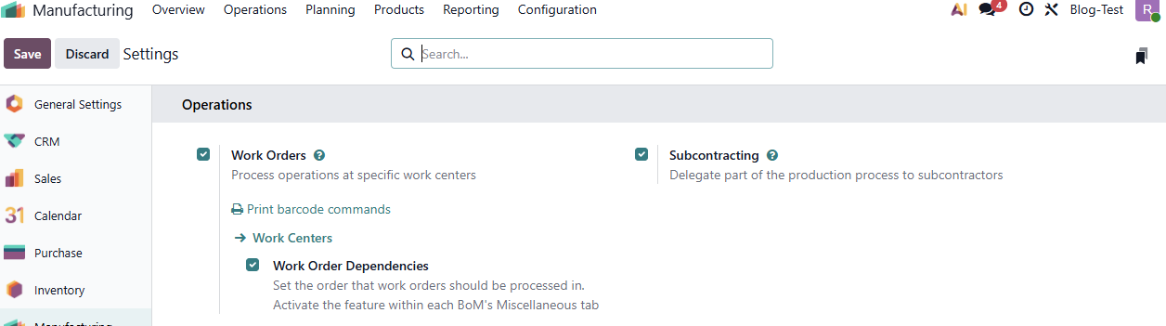
After saving, Odoo creates a few default work centers. These can be modified or replaced with the actual production stations from the factory.

Creating Work Centers
To create a new work center, open the Manufacturing application and navigate to the work center configuration.

Manufacturing Application => Configuration => Work Centers => New
On the work center form, fill in the name for the station along with a code (short reference) if necessary. Under production information section we can provide setup time and cleanup time required for the work center. OEE Target field is used to set a benchmark when tracking actual production performance. Time Efficiency field is used to calculate the expected duration of a work order at this work center.
We can also provide costing information such as hourly operating cost of the station. If needed we can select the employees who are allowed to use this work center by mentioning their names in allowed employees field, if left empty all employees can log in to the work center.

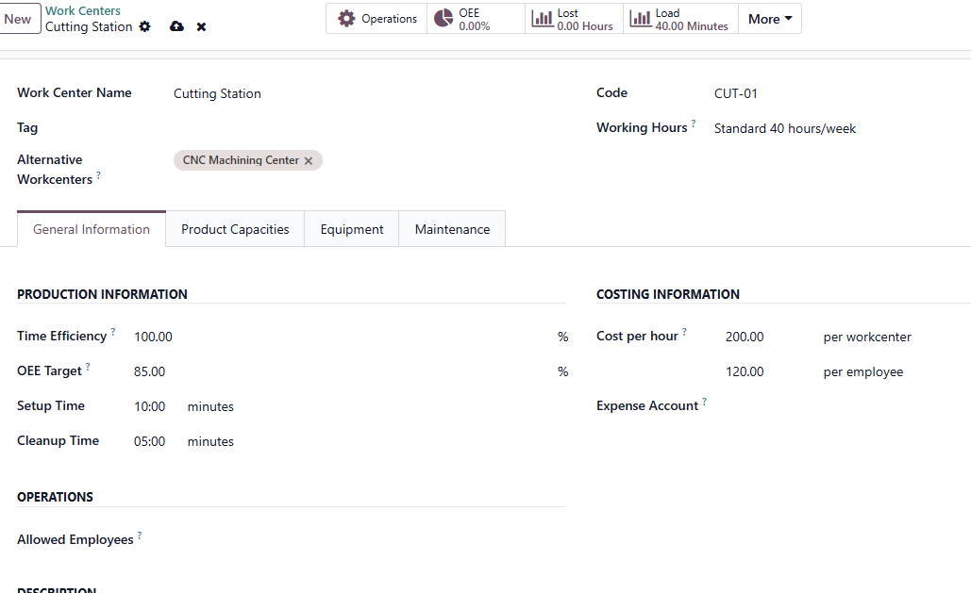
Additional settings available on the work center form include the Working Hours which defines the schedule of the station, Alternative work centers to set up backup work centers, the Product Capacities tab for setting up capacity of the work center, the Equipment tab to allocate equipment to this work center and finally maintenance tab to assign maintenance team for this work center.

Configuring Alternative Work Centers
Alternative work centers allow Odoo to route work orders to a backup station when the primary is at full capacity or unavailable. For example, if the factory has two assembly lines, one can be configured as the alternative for the other. When the primary assembly line is fully scheduled, Odoo can assign pending work orders to the alternative station instead.

Manufacturing Application => Configuration => Work Centers => Select the Work Center
Open the work center form and navigate to the Alternative Work Centers tab. Add the backup stations that can perform the same type of work. The alternative configuration can be mutual — Station A is an alternative for Station B, Station B can also be added as an alternative for Station A.
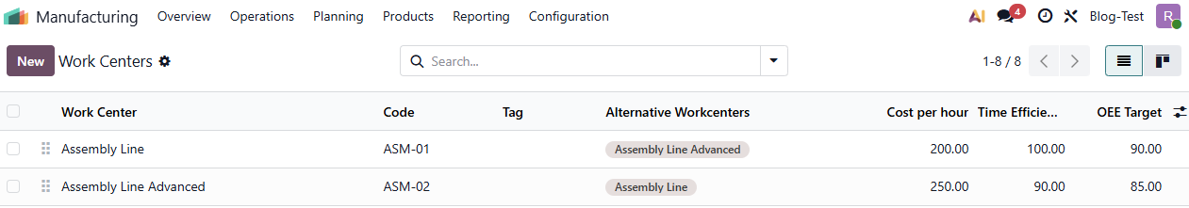

Creating the Product and Bill of Materials with Operations
Once work centers are configured, the next step is to create a product and define its manufacturing routing through operations on the Bill of Materials.

Manufacturing Application => Products => Products => New
Create the finished product with the product name, cost price and sales price.

Manufacturing Application => Products => Bills of Materials => New
Select the product and set the BoM type to Manufacture this Product.

Adding Components
In the Components tab, add all the raw materials and parts required to manufacture the product along with their quantities.
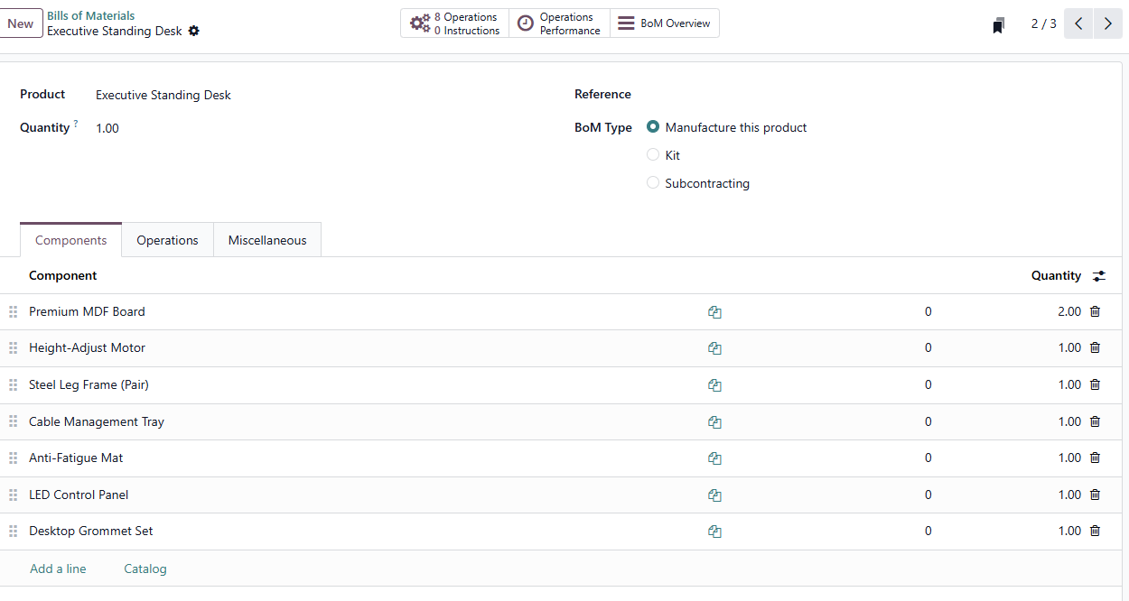

Adding Operations (Defining the Routing)
In the Operations tab, add the manufacturing steps in the order they should be performed. For each operation, specify the following.
Operation Name — A descriptive name for the step, such as Cut Panels to Size, Weld Frame or Final Packaging.
Work Center — The station where this operation will be performed. Select from the work centers created earlier.
Duration — The expected time in minutes for completing the operation on one unit of the product. This is the cycle time and does not include setup or cleanup — those are automatically added from the work center configuration.
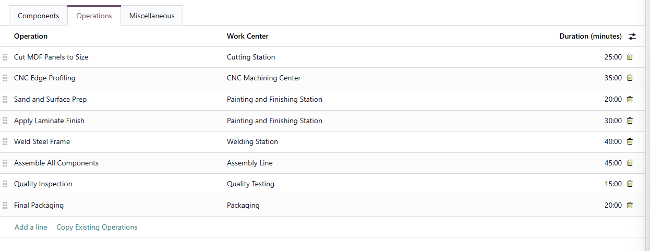
Operations can be reordered by dragging them into the desired sequence. The order of operations on the BoM determines the order in which work orders are generated and executed.
For example, a standing desk might have the following routing — cutting raw panels, CNC machining for edge profiling, sanding and surface preparation, applying finish, welding the metal frame, assembling all components, quality inspection and final packaging. Each step is assigned to the appropriate work center with its expected duration.

Creating and Confirming a Manufacturing Order
With work centers and routing configured, the workflow is executed through a Manufacturing Order.

Manufacturing Application => Operations => Manufacturing Orders => New
Select the product, enter the quantity and select the Bill of Materials. Click Confirm.
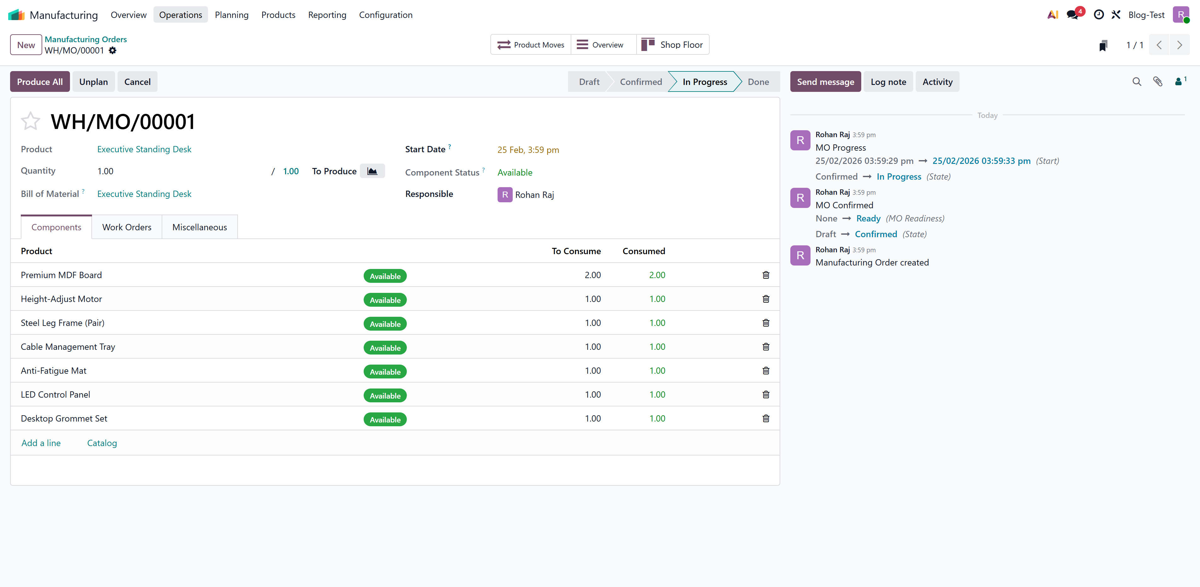
After confirmation, Odoo generates Work Orders — one for each operation defined on the BoM. Each work order is assigned to its respective work center and appears in the Work Orders tab of the Manufacturing Order. The first work order is set to Ready while the remaining work orders are in Waiting status until the preceding operation is completed.
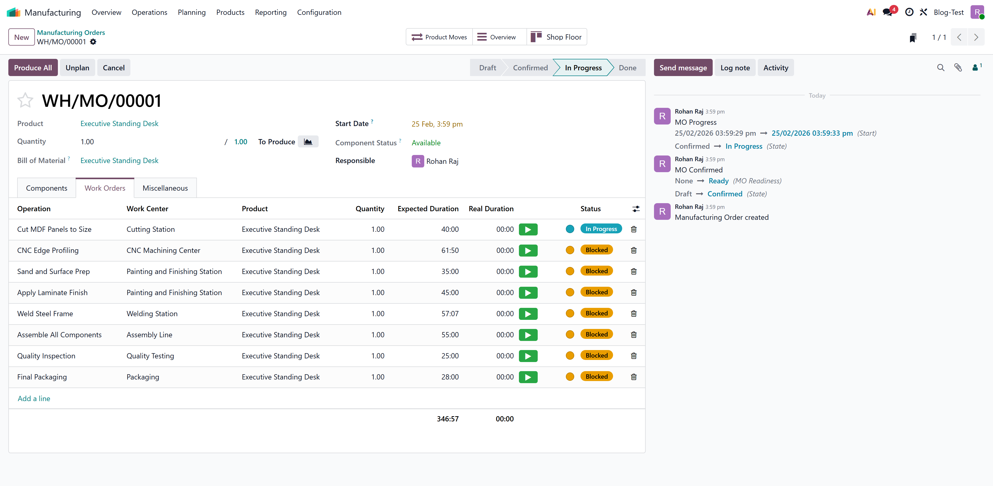

Executing Work Orders
Work orders can be executed from multiple locations within the application.

From the Manufacturing Order
Open the Manufacturing Order and navigate to the Work Orders tab. Each work order can be opened individually. Click Start to begin the timer, perform the operation and click Done when complete. The next work order in the sequence automatically moves to Ready status.

From the Shop Floor Module

Manufacturing Application => Operations => Manufacturing Orders => Open the Manufacturing order =>Shop Floor
The Shop Floor module provides a tablet-friendly interface for production operators. Each operator can see the work orders assigned to their station, start and pause timers, record quantities produced and mark operations as complete. This interface is designed for use on the factory floor without needing to navigate the full back-office interface.
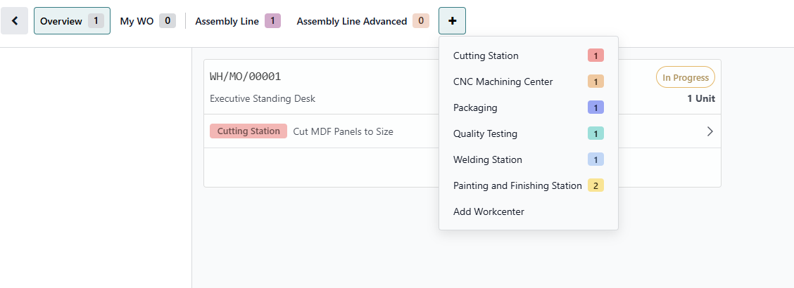

From the Planning View

Manufacturing Application => Planning => Planning by Workcenter
The planning view shows all scheduled work orders across all work centers in a Gantt chart format. This view helps production managers identify scheduling conflicts, see which stations are overloaded and when capacity is available.
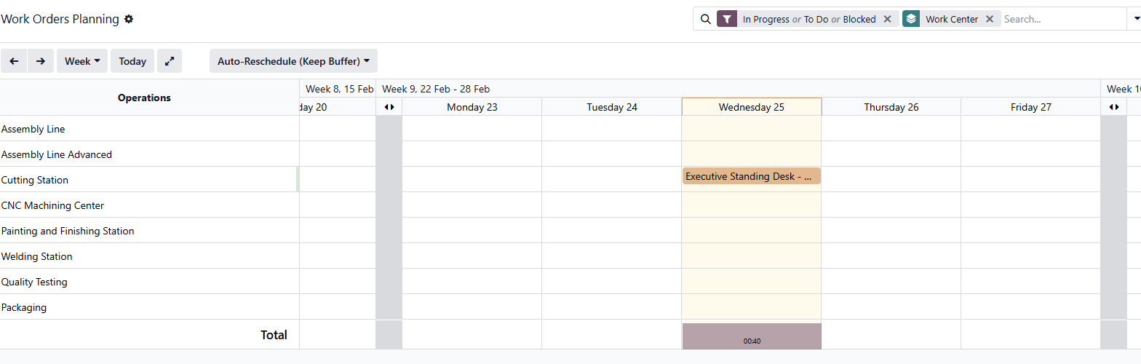

How Manufacturing Cost Is Calculated
When work centers are configured with a cost per hour, Odoo calculates the manufacturing cost of each operation by combining the production duration, setup time, cleanup time and the station's time efficiency.

Manufacturing Application => Operations => Open a completed MO => Overview

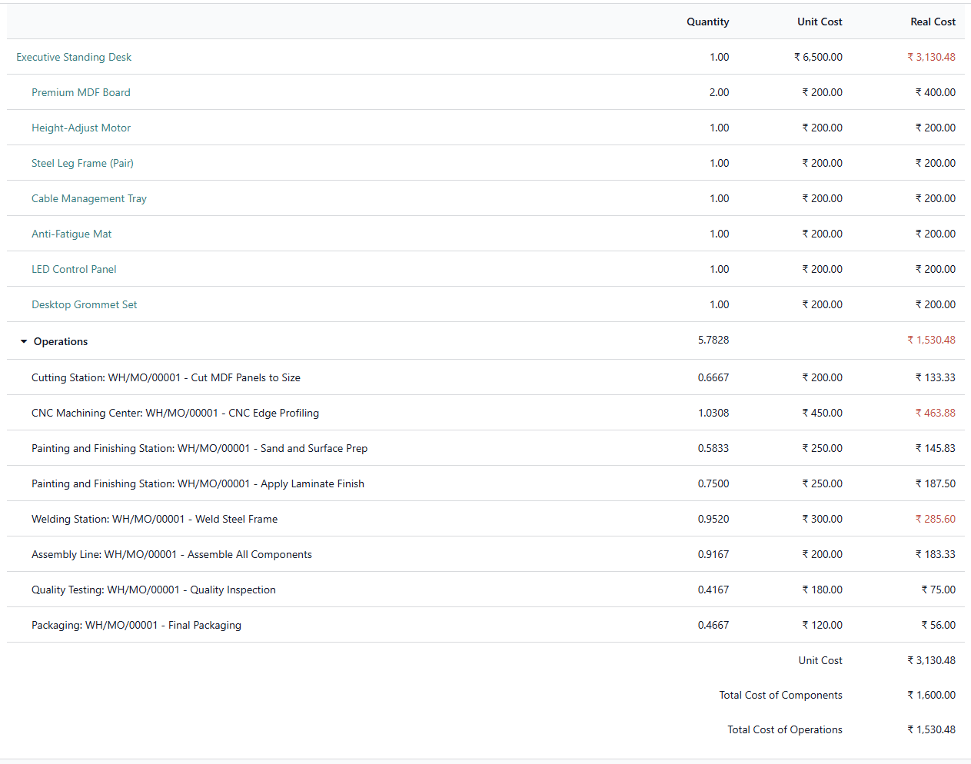
For each operation, the total time includes the cycle duration plus the setup and cleanup times from the work center. If the time efficiency is less than 100 percent, the effective duration is increased proportionally. The cost is calculated by multiplying the effective time by the cost per hour of the work center.
For example, consider an operation with a cycle duration of 40 minutes at a work center that has a setup time of 10 minutes, cleanup time of 5 minutes, time efficiency of 95 percent and cost per hour of 300. The total time before efficiency adjustment is 55 minutes (40 + 10 + 5). Dividing by the efficiency (55 / 0.95) gives an effective duration of approximately 57.89 minutes. The cost for this operation is (57.89 / 60) multiplied by 300(cost per hour of work center), which works out to approximately 289.47 per unit.
The total manufacturing cost per product is the sum of all operation costs plus the total component cost.

OEE Tracking
When operators use the Work Order interface to start, pause and complete operations, Odoo automatically collects data to calculate OEE for each work center. OEE is composed of three factors — Availability (percentage of scheduled time the station was running), Performance (actual speed versus expected speed) and Quality (good units versus total units produced). The combined OEE percentage is compared against the OEE Target configured on the work center.
OEE data is available in the Manufacturing reporting section and provides insights into which stations are performing well and which need improvement.

Manufacturing Application => Reporting => Overall Equipment Effectiveness
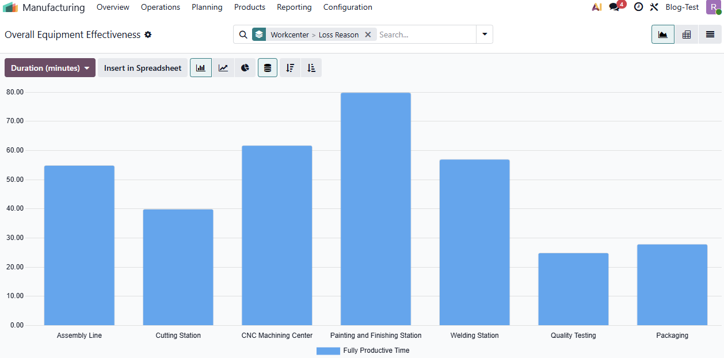

Conclusion
Work Centers and Routing in Odoo 19 bring structure and visibility to the production floor. By defining each factory station with its cost rate, setup and cleanup times and efficiency parameters, and by listing the sequence of operations on the Bill of Materials, businesses enable Odoo to schedule production accurately, calculate detailed manufacturing costs per operation, generate trackable work orders for operators and measure station performance through OEE. The configuration is a one-time setup effort that improves planning and cost accuracy for every Manufacturing Order created.

